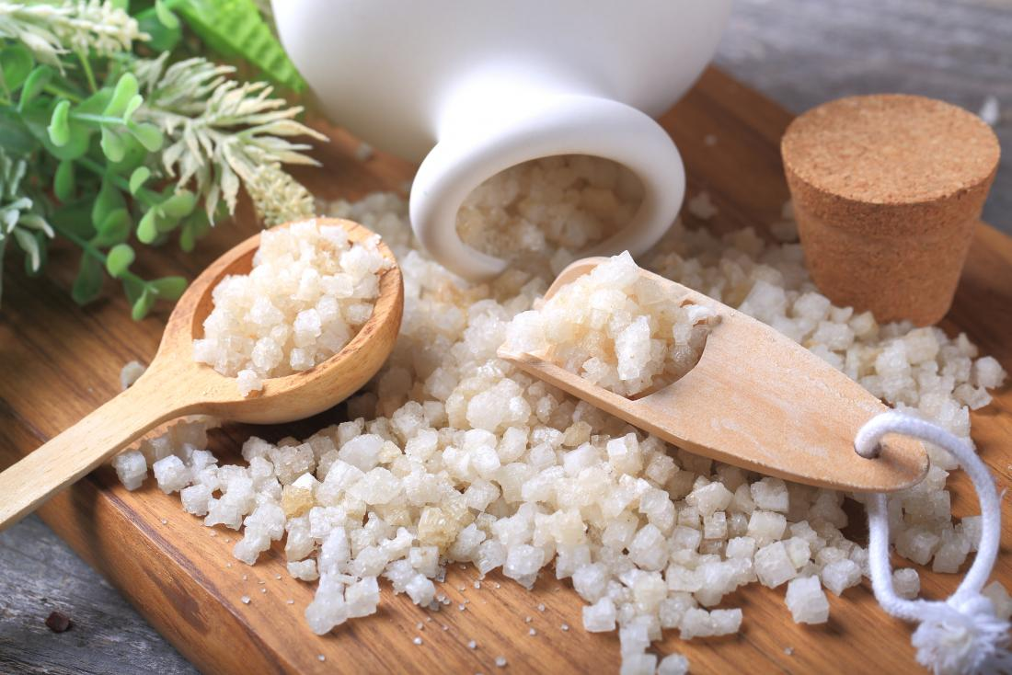
Benefits of Epsom salt baths
An Epsom salt detox is a warm bath with Epsom salt that may help improve the body’s natural detoxification process relaxation, stress relief and promote healing.
The two main ingredients of Epsom salt are magnesium and sulfate. Magnesium is a natural substance that aids a variety of bodily functions, including the removal of toxins. Sulfate can strengthen the walls of the digestive tract and make releasing toxins easier.

Soothe the skin
Epsom salt bathwater can soften rough, dry skin, and exfoliate dead skin cells. It may also soothe skin affected by skin conditions, including eczema and psoriasis. It is a good idea to check with a doctor before soaking in Epsom salt if a person has a skin condition, as it may make the symptoms worse.

Reduce soreness and pain
An Epsom salt bath may provide pain relief and reduce swelling in people living with certain types of inflammatory conditions, such as rheumatoid arthritis (the body's immune system attacks the lining of the joint capsule, a tough membrane that encloses all the joint parts. This lining (synovial membrane) becomes inflamed and swollen.), lupus (body's immune system attacks your own tissues and organs (autoimmune disease). Inflammation caused by lupus can affect many different body systems — including your joints, skin, kidneys, blood cells, brain, heart and lungs.), gout (form of arthritis that can affect anyone. It's characterized by sudden, severe attacks of pain, swelling, redness and tenderness in one or more joints, most often in the big toe.), and psoriatic arthritis (Psoriatic arthritis is a form of arthritis that affects some people who have psoriasis, Arthritis is the swelling and tenderness of one or more joints). Low levels of magnesium can ease the pain in people with arthritis. Epsom salt contains magnesium and may help the body get rid of toxins responsible for exacerbating inflammation while also reducing swelling, stiffness, and pain.

Reduce stress

Healthy magnesium levels can boost brain neurotransmitters that are responsible for inducing sleep and reducing stress. Magnesium may also promote melatonin, a sleep-inducing hormone. Some research has foundTrusted Source that people who are suffering from mental and physical stress benefit when their magnesium levels are managed.

Promote foot health

Epsom salt may help treat athlete’s foot and ingrown toenail infections. A person can bathe in a tub with Epsom salt water or soak feet in warm water and Epsom salt to help feet heal faster and relieve itching and help reduce foot odor.

Draw out splinters

Splinters can be difficult to remove without pushing them further into the skin. Soaking in an Epsom salt bath for a few minutes can reduce inflammation in the affected area, soften the splinter, and make it easier to remove.

How to take an Epsom salt detox bath

It is recommended to only purchase Epsom salt that has USP on the label, which means it has been tested for human use, according to standards set by the United States Food and Drug Association (FDA).
The packaging should have ingredient and drug fact information printed on it. Epsom salt can be purchased at a health food store, some pharmacies, or online.
To take an Epsom salt bath, add 2 cups of Epsom salt when running a bath in a standard size bathtub. The salt will quickly dissolve if put under running water.
The water should be warm but not too hot. Temperatures between 92°F and 100°F (33°C and 37°C) are ideal. Soak in the bath for 12 to 20 minutes, or longer if desired. Rest for at least 1 hour after a detox bath or take a bath at bedtime and go to sleep afterward.

