Feeding our Plants
It’s more than you can imagine!
- Mathew 13:3-8
Behold, a sower went out to sow. And as he sowed, some seed fell by the wayside; and the birds came and devoured them. Some fell on stony places, where they did not have much earth; and they immediately sprang up because they had no depth of earth. But when the sun was up, they were scorched, and because they had no root they withered away. And some fell among thorns, and the thorns sprang up and choked them. But others fell on good ground and yielded a crop; some a hundredfold, some sixty, and some thirty.

- What are the first things you will need for our new little plants?
  - A place for the garden
  - Sunshine
  - Food “fertilizer”
  - Water easily available
  - Lots of attention, keeping an eye on them to protect them daily if possible.

- Remain on the offensive.
  - Our goal is to have a PRODUCTIVE ABUNDANT HARVEST
  - Plants need regular:
    - Nutrients … a variety of “meals”
    - Sunshine … in abundance
    - Water …. frequently (with understanding of plant type)
    - Pruning and supportive structures
    - Protection …. Companion planting

- Different kind of Plant Food
  - Nature provides food that carries plants from the beginning of seed sprouting to the end of their productive life.
    - Plant-based fertilizers:
      - Compost
      - Ground seed meals
    - Animal-based fertilizers:
      - Worm castings
      - Manures
      - Blood and bone meal
    - Mineral Resources
      - Rock dust
      - Green sand
    - Sea nutrients:
      - Kelp meal
      - Fish emulsion

Fertilizers have three main chemicals that can effect the development of our plants.
- We first think of fertilizer or manure.
  - Fertilizer is made up primarily of the following chemicals.
  - Nitrogen (N)
  - Phosphorus (P)
  - Potassium (K)
- When shopping for fertilizer and manure, these three will be listed in a number form on the bag.
  - Example: 5-5-5, 2-5-2, 10-10-10, 12-14-12 etc.
    - The first # will be N
    - Second # will be P
    - Third # will be K

- Common Organic fertilizers
  - Some most common organic fertilizers
  - Alfalfa Meal: 2.5% N, 1% P, 1.5% K
  - Bat Guano: 8% N, 6% P. 1% K
  - Fish Emulsion: 9% N, 0% P, 0% K
  - Cow Manure: 2.5% N, 1% P, 1.5% K
  - Soybean Meal: 3% N, 0.5% P, 2.5% K
  - Bone Meal: 4% N, 20% P, 0% K
  - Fish Meal: 10% N, 5% P, 4% K
  - Compost or manure etc.
  - Cow Manure is a great all-purpose manure.
  - Chicken Manure is more concentrated and a little goes a long way.

- Sunlight
    - How does sunlight affect our plants?
    - All plants require light for photosynthesis, the process within the plant that converts light, oxygen, and water into carbohydrates(energy).
    - Plants require this energy to grow, bloom and produce seed. Without adequate light, carbohydrates cannot be manufactured, the energy reserves are depleted, and the plant dies.
    - You may eventually produce the fruits and roots, but without the correct amount of sunlight, it will take longer, and you might not have enough time in your season to have a good harvest.
      - How many hours of sunlight does your garden get during your growing season.
      - Beans, Peas, Root crops need 6 hours per day.
      - Greens: 2-4 hours per day
      - Herbs: 4+ hours per day
      - Tomatoes, Peppers, Squash, need 8 hours per day.

      - Garden Space Location Location Location

- Where is the sun in your garden space?
- What time of year is it that you are planting?
- What do you want to plant?
  - Cool weather plants … peas, lettuce, spinach
  - Warm weather … tomatoes, peppers, beans

- Your zone will determine what you can plant and when.
- We live in zone 6A.
- Guaranteed to not have frost after May 17 – Sept 26

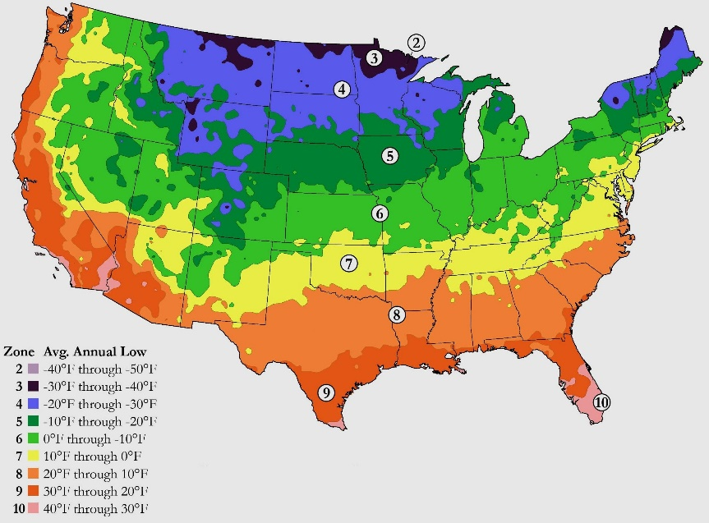

- Fertilizer root at different stages of growth.

  - Strong rood structure … the first stage of growth
    - Potassium (K) helps determine the root health of our plants. Their ability to grow big and to take up water and nutrients.
    - Green sand and Kelp meal are both great sources of potassium (K).

  - Leaf Growth … the next phase of growth
    - For some plants, like lettuce and kale, that may be our goal, and now that we have strong roots, we can use stronger nitrogen (N) sources, like chicken and rabbit manure.

  - Fruiting plants … the last stage of growth
    - Once the plant starts to produce a good number of leaves and stem, we want to add phosphorous (P)
    - This will help the flowering and fruiting.
    - We will need pollinator-friendly plants in and around our garden. Flowers that will attract butterflies, bees and insects that will do the work for us.
    - Once the flowers turn to fruit, continue to feed our plants phosphorous-rich foods.
    - Good sources of P are rock dust, bone meal, and finished “processed” animal manures.
Watering:
- Another essential part of feeding our gardens is water.
  - The garden needs about 1 inch of water a week
    - Check how hot/cold/wet or dry it is
    - Check the moisture of the soil every few days.
  - Rainwater is the best.
    - It provides dissolved minerals that feed our plants.
    - We can collect rainwater from our gutters.
    - Tap water is treated and can sometimes negatively affect the plants.
    - development.
Exercise:
- We provide the exercise to help our garden be successful.
  - Bending over to plant the seeds and check the progress.
  - Provide the support they need.
    - Stretching up to tie the branches as they start to fall over.
    - Keep the harmful pests out of the garden.
    - Prune and trim the excess that can cause disease to enter the plants.
    - Kneel to tend to the weeds and assess the soil need.

“The seed is the word of God” Luke 8:11
- In the beginning God Created the Garden of Eden for our pleasure and joy
- Jesus spoke and it was good.
- Satan is our pest and weeds that come in to destroy our joy and the fruits of our labor.
- Our Christian families are the companion “plants” that help keep us as healthy as we can be in this world.
- As we kneel and pray daily, Jesus helps protect us by making sure the sunlight, fertilizer and the watering is just right.
- We then can enjoy and harvest the fruits of our labor from our garden and in heaven.

Reference sources:
NKJV New King James: version of the Bible
Kitchen Garden Revival: Nicole Johnsey Burke of Gardenary

